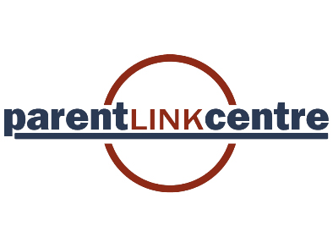
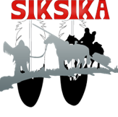
- Parent/Guardian

Name: |  | Spouse/Partner Name:
AHC#: |  | AB Health Care#:
Treaty #: |  | Treaty #:
Address: |  | Town:
Postal Code: |  | Email:
Telephone: |  | Cell:

- Parenting Status
□ Single | □ Blended Families | □ Married/Common-Law | □ Separated | □ Foster Parent (s)

What community do you live in?
Map & House #:
Are you First Nations?
What First Nations community are you from?
How long have you lived in Siksika?

- Children
Name: |  | Gender: | □ Female | □ Male
D.O.B: |  | Allergies:
AHC#: |  | Treaty#:
 |  | Band:

Name: |  | Gender: | □ Female | □ Male
D.O.B: |  | Allergies:
AHC#: |  | Treaty#:
 |  | Band:

Name: |  | Gender: | □ Female | □ Male
D.O.B: |  | Allergies:
AHC#: |  | Treaty#:
 |  | Band:

Name: |  | Gender: | □ Female | □ Male
D.O.B: |  | Allergies:
AHC#: |  | Treaty#:
 |  | Band:

Is this your first time with Siksika Parent Link Centre? □ Yes □ No
How did you hear about us? (Check all that apply)
□ Newspaper □ Flyer/Brochure □ Social Media □ Word of Mouth

□ Other:_________________________________________________

- Programs you are interested in:
□ Triple P | □ Community Resources | □ Family Activities
□ Child Development | □ One-on-One Support | □ Crafts
□ Elder Visits | □ Woman’s Circle | □ Dad Programs

- Emergency Contact Information
 | Name: |  | Home#:
 | Relationship: |  | Cell#:
 | Name: |  | Home#:
 | Relationship: |  | Cell#:

- Medical Information

I/We understand that if I____________________ or My Child is in need of medical assistance please contact 911 or if my/our child is filling ill I/We can be contact and pick up the child.

Parent/Guardian Signature: |  | Date:

- Parent’s/Guardian’s Consent

I/We have read and understand the information presented in this packet. I/We are aware and understand that activities include (Trips, walks, story-telling by an Elder, and other activities) may involve minor injuries. I/We agree to cooperate with all Siksika Parent Link Center’s procedures and regulations. My/Our child may be photographed and pictures released for publicity on the Website and any Siksika Family Services purposes. I/we are fully informed about the risks associated with participation in the activities and consent to our child’s participation in the Siksika White Buffalo/Siksika Parent Link Centre programs.

Parent/Guardian Signature: |  | Date:

- PHOTOGRAPH/MEDIA CONSENT AND RELEASE

I hereby consent and authorize an employee or agent of Siksika Parent Link Center to take photographs or motion pictures of my child; or to produce videotapes, audiotapes, closed circuit television programs, web casts, or other types of media productions that capture my child name, voice, and/or image (any of the foregoing types of media are called the “Materials” in this Consent and Release form).
I authorize Siksika Parent Link Center to copyright the Materials, and I authorize Siksika White Buffalo to use, reuse, copy, publish, display, exhibit, reproduce, license to third party, and distribute the Materials in any educational or promotional materials or other forms of media, which may include, but are not limited to Siksika White Buffalo publications, catalogs, articles, magazines, recruiting brochures, websites or publications, electronic or otherwise, without notifying me.
I agree that I am participating on a voluntary basis and I will not receive any payment from Siksika Parent Link for signing this release or as a result of any publication of the Materials.
I represent that I am at least 18 years of age, or if not, that I have secured the signature of my parent or legal guardian.
Print Name |  | Signature: |  | Date:
Witness Name |  | Signature: |  | Date:

